ENVIRONMENTAL HEALTH AND SANITATION UNIT
REPORT ON EDUCATION/SENSITIZATION AT SHUKURA, FREEDOM AND TARKORADI STATION/DAN LARTEY MARKETS FOR SECOND QUARTER,2023 (APRIL -JUNE)
INTRODUCTION
Cleanliness and personal hygiene are important part of any business. It affects health, wellbeing and appearance of a person. Increasing one’s personal hygiene standards at market place can have several advantages and this also lies in how others perceive your business. A clean environment will send the message that, one is well organized, capable and committed in the eyes of their customers. A cleaner market will help both vendors and customers stay healthier and customers that are comfortable and healthy are more likely to feel happier purchasing food and products in the market by the vendors which can lower the high rate of sick people and days in the environment. Clean market places are less likely to cause injuries or any form of bacteria and viruses. Hygiene standards are more important now than ever before, with health fears and customers concerned about the safety of themselves and their families, it is up to one to create a clean market place where they can earn their profits with minimal health risk.
OBJECTIVES
- To prevent the spread of infectious diseases and helping people live long healthy lives
- To hygienically separate human manure from human contact and therefore reduce the exposure to contamination
- To increase the knowledge of food venders on food safety issues.

ACTIVITY
A team of Environmental Health Officers led by Madam Patricia Nyarko Anokye went to Shukura, Freedom and Tarkoradi Station/Dan Lartey Markets to educated market women and food handlers on the need to ensure good personal hygiene that is, washing of hands after visiting the washroom also cutting of finger nails short and clean to avoid the harboring of germs, displaying of food stuff above 3ft from the ground, protecting food from dust and flies, proper storage of refuse, avoid open burning and encourage the use of improve stove, cleaning of drains in-front and behind their business premises and also avoid dumping of refuse into drains which is likely to cause flooding and breeding of mosquitoes.
Environmental health officers took food vendors through the need to always be in head gear, apron and the need to get tested and acquire medical health certificate. They were also taken through proper food storage and preparation eg. Not to mix cooked and raw food and store in the same fridge to avoid cross contamination.
CONCLUSION
The health Promotion and Education activity was very successful and participation rate was high.
This is a very nice and educative program that need to be taken place very often.

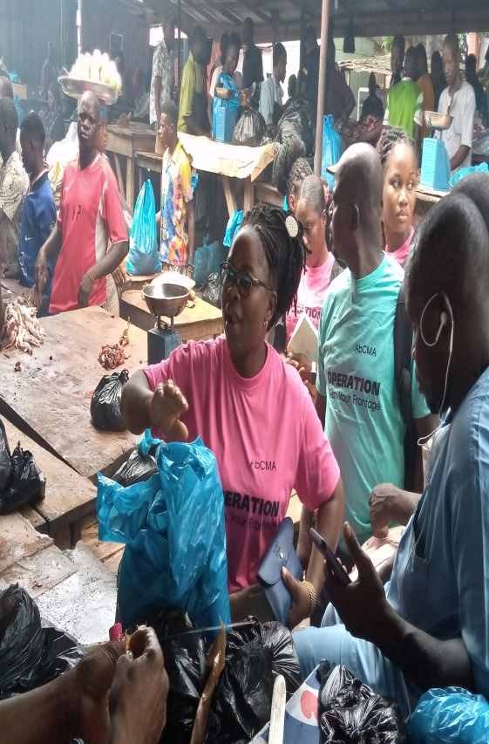
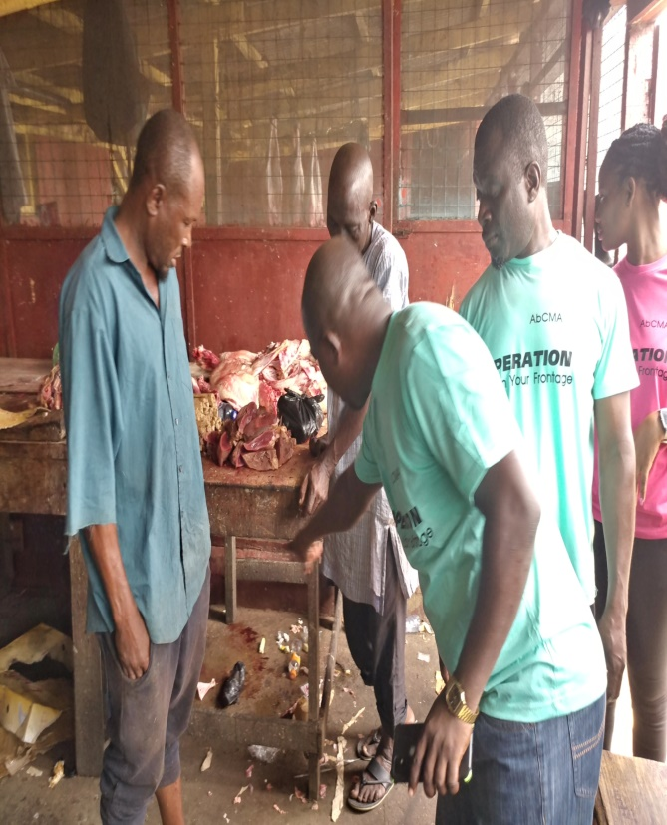


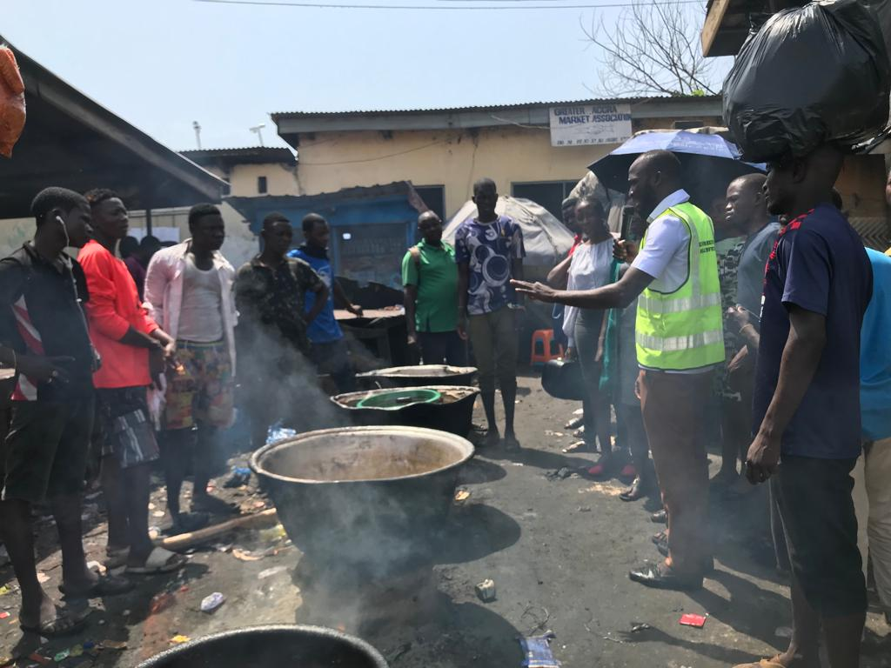

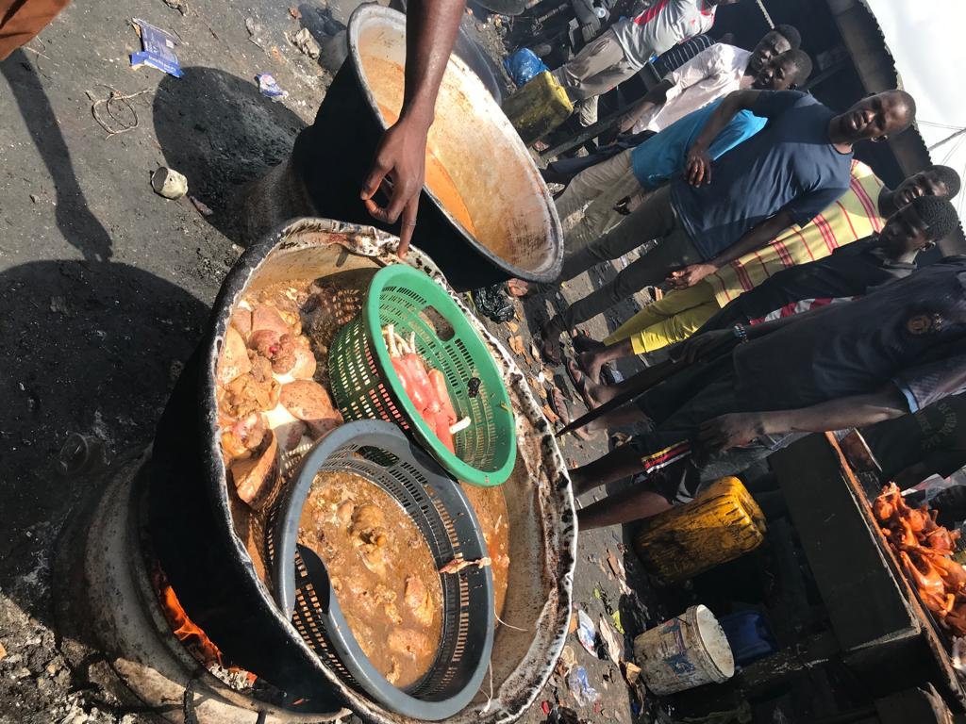



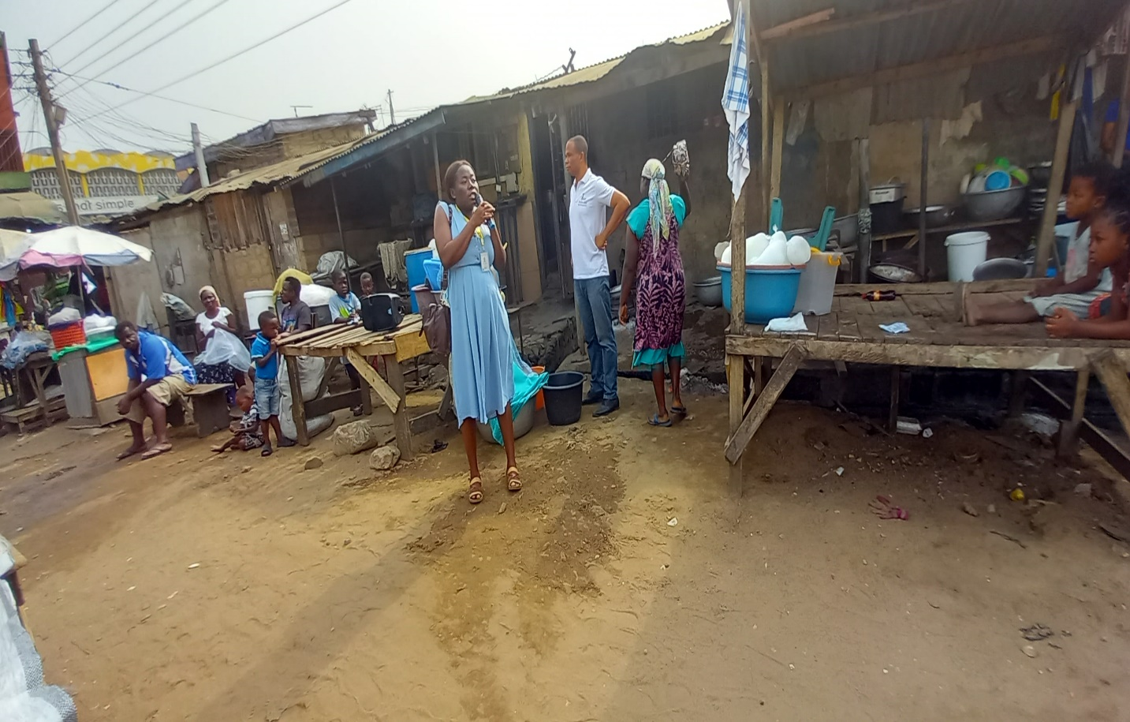

COMPILED BY:

BRIDGET SEYRAM DIAPIM
MUNICIPAL ENVIRONMENTAL HEALTH OFFICER

